1.Create a shell script to print the HTTP error code of guvi.in & print, the success/failure message based on the error code response.

vi app.sh

#!/bin/bash

read -p "Enter the website to check the HTTP error code: " URL

http_code=$(curl --write-out %{http_code} --silent --output /dev/null $URL)

if [ $http_code -eq 200 ]; then

echo "The Response code of $URL is : $http_code"

echo "The HTTP connection is Success"

else

echo "The Response code of $URL is : $http_code"

echo "The HTTP connection is Failure"

fi

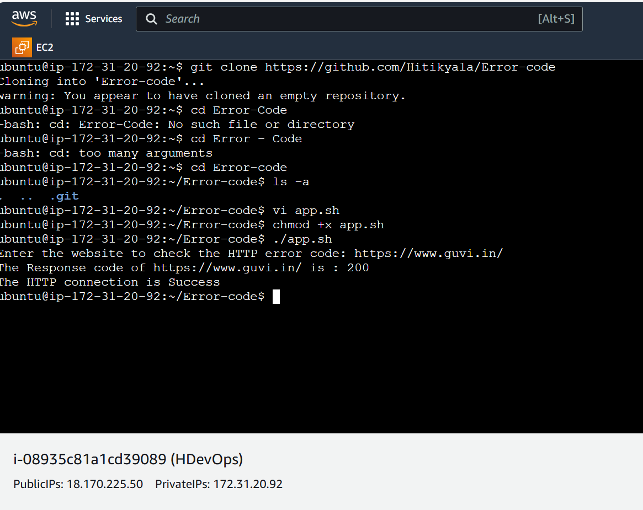

2.Given a file, replace all occurrence of the word ""give"" with ""learning"" from the 5th line till the end in only those lines that contain the word "welcome"

vi sample.txt

1. The host will give you a warm welcome at the door.

2. Please give your guests a friendly welcome.

3. We give a special welcome to all our new members.

4. The team will give a hearty welcome to the new coach.

5. She plans to give him a grand welcome home.

6. The community will give you a generous welcome.

7. They give a formal welcome to the visiting dignitaries.

8. He promised to give a cheerful welcome to all attendees.

9. The school will give a joyful welcome to the incoming students.

10. Let's give them a sincere welcome to our neighborhood.

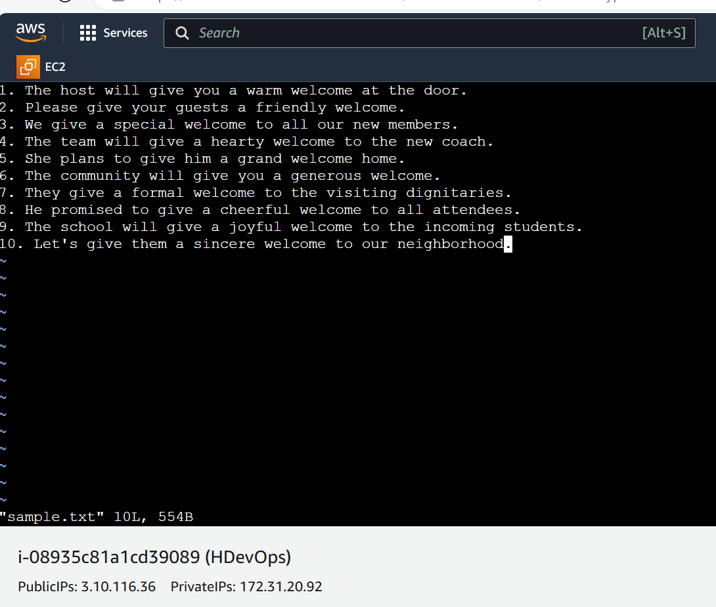

Replacing the words.

vi replace-words.sh

#!/bin/bash

sed -e '/welcome/{5,$s/give/learning/g}' sample.txt > newsample.txt

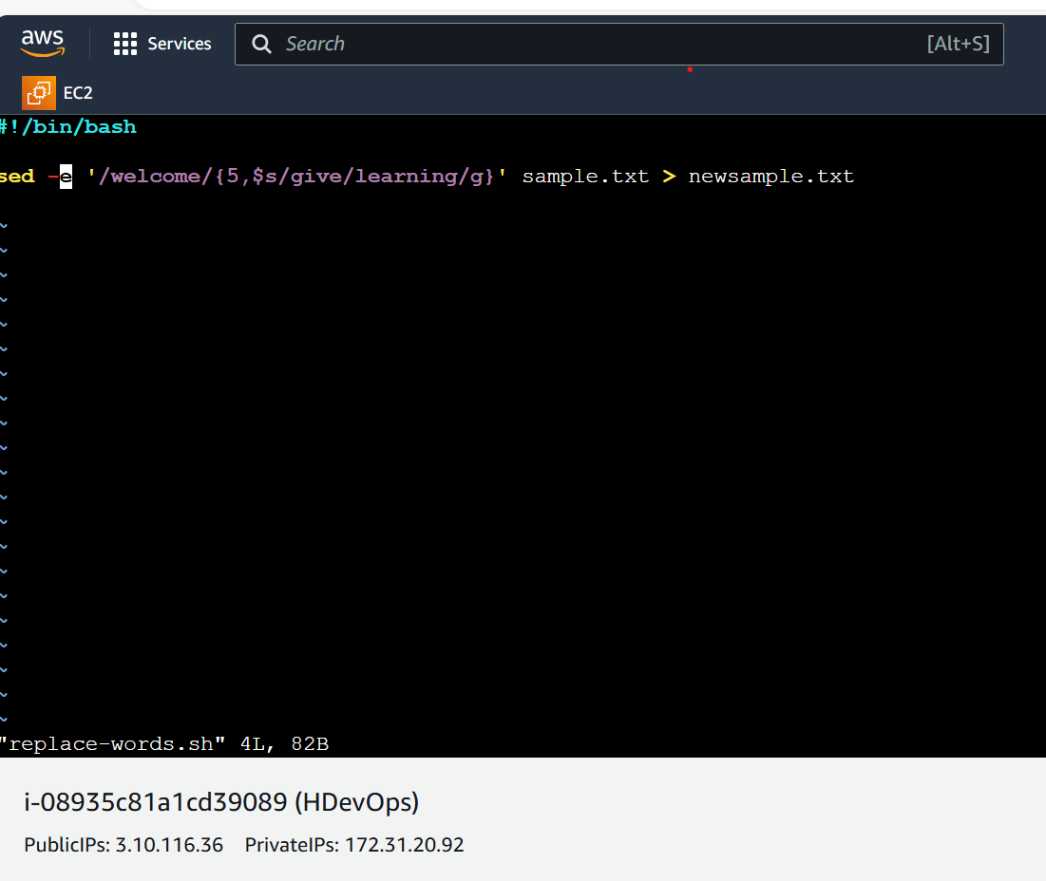

Replaced Words.

1. The host will give you a warm welcome at the door.

2. Please give your guests a friendly welcome.

3. We give a special welcome to all our new members.

4. The team will give a hearty welcome to the new coach.

5. She plans to learning him a grand welcome home.

6. The community will learning you a generous welcome.

7. They learning a formal welcome to the visiting dignitaries.

8. He promised to learning a cheerful welcome to all attendees.

9. The school will learning a joyful welcome to the incoming students.

10. Let's learning them a sincere welcome to our neighborhood.

